Module: BSHCSD4 / BSHCDBT / BSHCYB4 / BSCCYBE4 — Cloud Application Development
Student: Rahul
Submission of project : 31/07/2026
GitHub repository: https://github.com/rahul1862/Rahul-Cloud-Project
Backend API: https://rahul-cloud-project-2.onrender.com
Deployed URL: https://rahul-cloud-project-3.onrender.com
Video demonstration: [TO BE ADDED]

ABSTRACT
UserHub is a contact directory and SaaS application. My project has been built using a REST backend and I am using Node.js, Exxpress, PostgreSQL and the frontend is React and tailwind css for the styling of my application. The brief asked for CRUD on contacts, which I did. I also built a custom PDF library that works, tested at five levels (unit through system), and set up a GitHub Actions pipeline that won't let broken code get deployed. This report walks through what I built and how I tested it.

1. INTRODUCTION
One thing UserHub does is assist small teams with contact management. You can add, search, edit, remove, and export someone's information as a PDF. Additionally, I included a dashboard that displays the number of contacts you have as well as the most popular email domains. The following learning objectives are covered by this project: In LO1, I worked on web frameworks and SAAS patterns; in LO2, I built and implemented a real application; and in LO3 and LO4, it does testing and CI/CD.
1.1 Motivation and the problem
Every small business needs a contact directory. But Salesforce and HubSpot are overkill and in my opinion they're built for pipeline management and marketing automation. You don't need that. You need to know who works here and what their email is.
UserHub does exactly that. Five-minute setup. Works immediately. Costs nothing and its free to run on Render. It has a Proper CRUD, working search, a quick dashboard, one-click PDF business cards and has a finance section where you can manage expenses and profit and loss in each of your company
1.2 What I built
The brief required me to make a full CRUD on a user I have added a name,email,address, phone number and joined date, a REST API was used for the frontend and it calls over HTTP, server side violation and I have added database level duplicate email checking , finance section which manages company profit and loss and a custom library that does PDF generation and I have added five layers of testing unit , integration, functional, smoke and system tests and I have done continuous integration so the application runs all the tests during production so I can catch errors before application is deployed
2. System Architecture
Two separate Node projects. Frontend and backend live completely apart—different package.json files, different dependencies, different test suites. They only talk through REST calls to /api. Neither imports code from the other. Figure 1 shows how everything connects and where it deploys. Here is my system architecture below
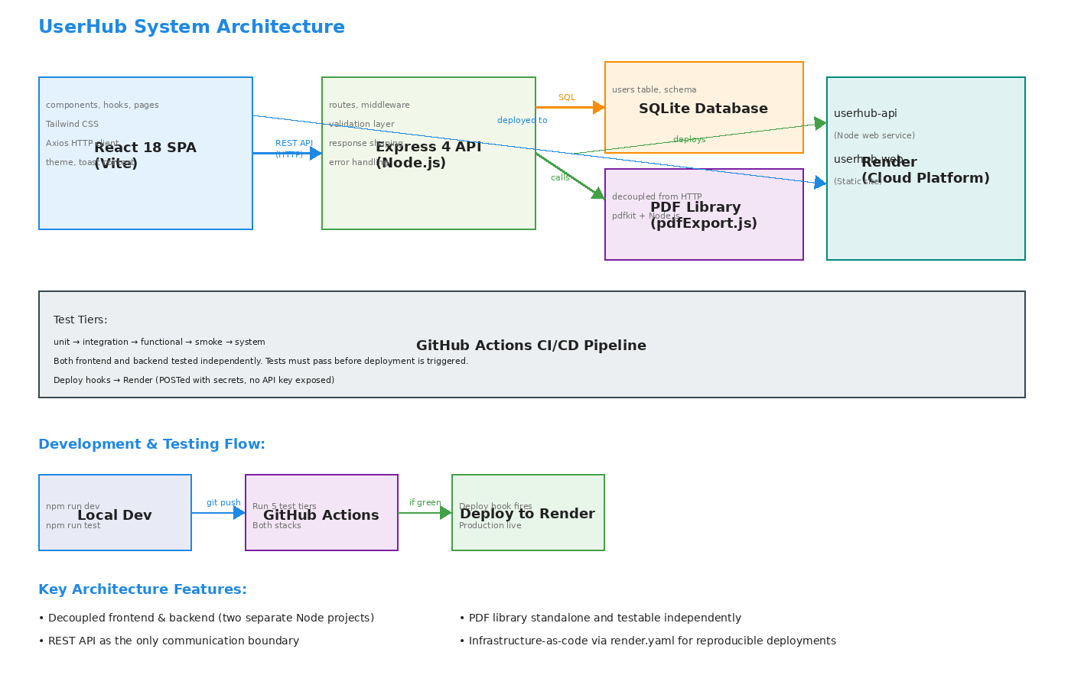
Figure 1: UserHub architecture — React calls REST API calls PostgreSQL, PDF library lives separately, GitHub Actions gates deployment.
2.1 The consequences of adding a contact
Moving through the flow:
(1) The form will be submitted by the user. You receive immediate feedback because it has already been locally validated in the system.
(2) POST /api/user will be visited by userService.createUser().
(3) The request is routed to the handler using Express.
(4) Server-side validation verifies everything once more. That is where truth originates.
(5) Business rule: see if the email address is already in use. Stop if it does.
(6) Add a timestamp and UUID to the row.
(7) The database row has been mapped to the JSON response format.
(8) Hook displays a success toast and modifies the user interface.
This is meant to be section 5. Every layer is tested in a different way.

3. BACK-END DESIGN
3.1 Framework and patterns
I have made this application on Express 4. The structure is straightforward in my opinion. The index.js starts the server.app.js has all the routes, middleware, handlers, validation logic. db.js is the database that runs the database and the schema in this project. The PDF generation is located in the lib/pdfExport.js and does not use the http method.The architecture is layered: the routes take requests, the database stores data, and toApi() translates the internal row structure into the public JSON API. Every SQL query uses parameterized statements. I never link user input directly into SQL, so SQL injection is impossible by design.
3.2 Data model
One of my table is called users with five columns: id is (UUID primary key and name is(required, unique) and email is(required,unique), address is(required and phone is (optional), createdAt is (ISO-8601 timestamp).
Using PostgreSQL through the pg connection pool. In production it is a managed PostgreSQL database, and in tests the application creates a fresh, uniquely named database for each run, so tests never touch real data. UUIDs instead of auto-incrementing IDs means you can't iterate through user IDs to spy on the directory.
On first startup, the database seeds itself with 40 realistic contacts across seven domains. Timestamps are spread over 102 days so when you deploy it, the dashboard metrics actually mean something instead of all zeros. Tests skip the seed data to stay deterministic.
3.3 REST API surface
Everything's under /api and returns JSON. Here's the complete surface:
POST /api/user — create a contact
GET /api/users — list all contacts
GET /api/user/:id — get one contact
PUT /api/user/:id — update a contact
DELETE /api/user/:id — delete a contact
GET /api/users/search/:query — search by name or email
GET /api/stats — dashboard metrics (total users, growth rate, domain breakdown)
GET /api/user/:id/pdf — download PDF business card
3.4 Validation and error handling
Every write is validated by name (required and atleast 2 character), email(required, valid format, unique), address(requires, at least 5 character), phone(optional). If validation fails, it will return an error 400 with a message that is readable and a per field error per object.
Duplicate emails get a error 409 message. Thats checks on and runs on create and on update users/companies , but it excludes the record that is being used currently being edited. If that was not the case you wouldn’t be able to save an unrelated change without it going over your own email
Unknown user IDs return 404 consistently.
Errors thrown inside the PDF route are caught and passed to Express's error middleware so the process never crashes.
The stats endpoint has explicit handling for division-by-zero if it has a 100% growth when last week had zero signups, 0% when both weeks are zero so NaN never escapes to the frontend.
3.5 Project structure
The server is small enough to read in one sitting. index.js, app.js, db.js, lib/pdfExport.js, and tests/ split by tier. Nothing hidden in framework boilerplate. Someone else that’s reviewing this can understand the whole backend without digging. Comments only appear for non-obvious stuff: the growth-rate edge cases, the stream-and-buffer pattern for PDFs, and why duplicate email checking excludes the current record on updates.
3.6 Transactions and Data and API
UserHub will keep track of transactions and income and expenses entries for a team. This team will be able to log these entries against their contacts or their general operations. We have a part that uses the same backend and the same architecture. This includes routes that handle HTTP and db.js that holds the schema. We also have toAPI() mappers that change the response.
The transaction table has six columns: id, which's a random UUID and the primary key type, which can be either 'income' or 'expense' category, which must be at least 2 characters, amount, which must be a positive number and date which must be a valid date. If any of these are not correct we get an error message with a code of 400. This error message also includes a list of errors for each field. This list is in the format that the frontend expects from the users endpoint. So the code that handles the form on the client side does not need a way to handle errors.
The /api/pnl endpoint is the really different part of the logic. It groups transactions by category and by month. Then it adds up the income. Subtracts the expenses for each group. Finally it returns the figures that the dashboard can use to make charts. This endpoint also handles division by zero in the way as the user stats endpoint. If there are no transactions, for a month it returns 0 of NaN. UserHub uses the transactions and data and API to make all this work.
3.7 Authentication and Authorisation
Access to the API is protected by token-based authentication. A dedicated authentication layer (lib/auth.js and routes/auth.js) issues JSON Web Tokens on a successful login and verifies them on every subsequent request. Passwords are never stored in plain text: they are hashed with bcrypt before being written to a separate auth_users table, and the stored hash is never returned to the client. On startup the system seeds a single demo administrator account, and public self-registration can be enabled or disabled through an environment variable.
A requireAuth middleware sits in front of every /api route apart from the public login, registration and health endpoints. It reads the Authorization: Bearer token header, checks the token signature and expiry, and rejects a missing or invalid token with a 401 response. The signing secret, token lifetime and admin credentials are all supplied through environment variables, so no secrets are committed to the repository.
3.8 Security Middleware and Rate Limiting
Alongside validation, the backend applies a layer of HTTP security middleware. Helmet sets a range of protective response headers, and explicit headers are added to disable content-type sniffing, block framing (clickjacking) and control the referrer policy. A request-size guard rejects oversized JSON payloads before they reach any handler.
Rate limiting is applied to blunt abuse. A general limiter caps the number of requests per IP against the API over a fifteen-minute window, a stricter limiter protects the login endpoint against brute-force attempts, and a tighter hourly limiter restricts how many new accounts a single IP can create. Health-check probes are exempted so that uptime monitoring is never throttled.
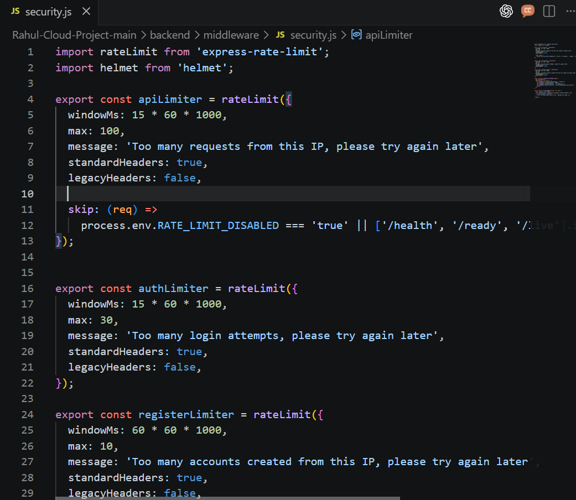
Figure 8: security.js — Helmet plus tiered rate limiting for the API, login and registration endpoints, with health probes skipped.
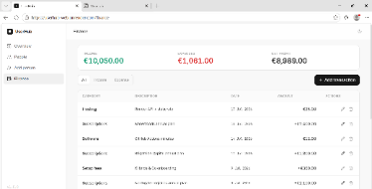

3.9 Finance

The Finance User Interface is made up of the TransactionForm.jsx. This form does the thing as the UserForm. It is used for creating and editing transactions. It also checks the information on the client side to make sure it is correct like the server does. If there is a problem with the information it shows an error message away.

There is a section for Finance in the sidebar. This section lists all the transactions in a table that can be sorted. It shows income and expenses separately. It also shows a summary of the information. This summary comes from the /api/pnl. It breaks down the totals by category and month.

The Finance section uses the way of managing information as the useTransactions hook. This hook handles the loading, error and data states. This means the pages do not have to worry about these things and can just show the information. The Finance section also uses the basic layout and empty or error message components that are used in other parts of the application. This means that the new code, for the finance feature is actually pretty small. The TransactionForm.jsx and the Finance section work together to make it easy to manage transactions. The Finance section is a part of the Finance User Interface.

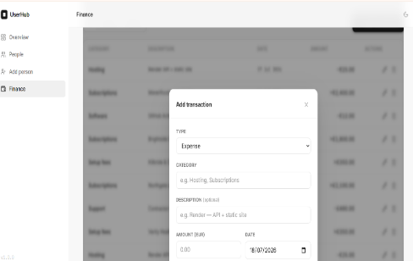
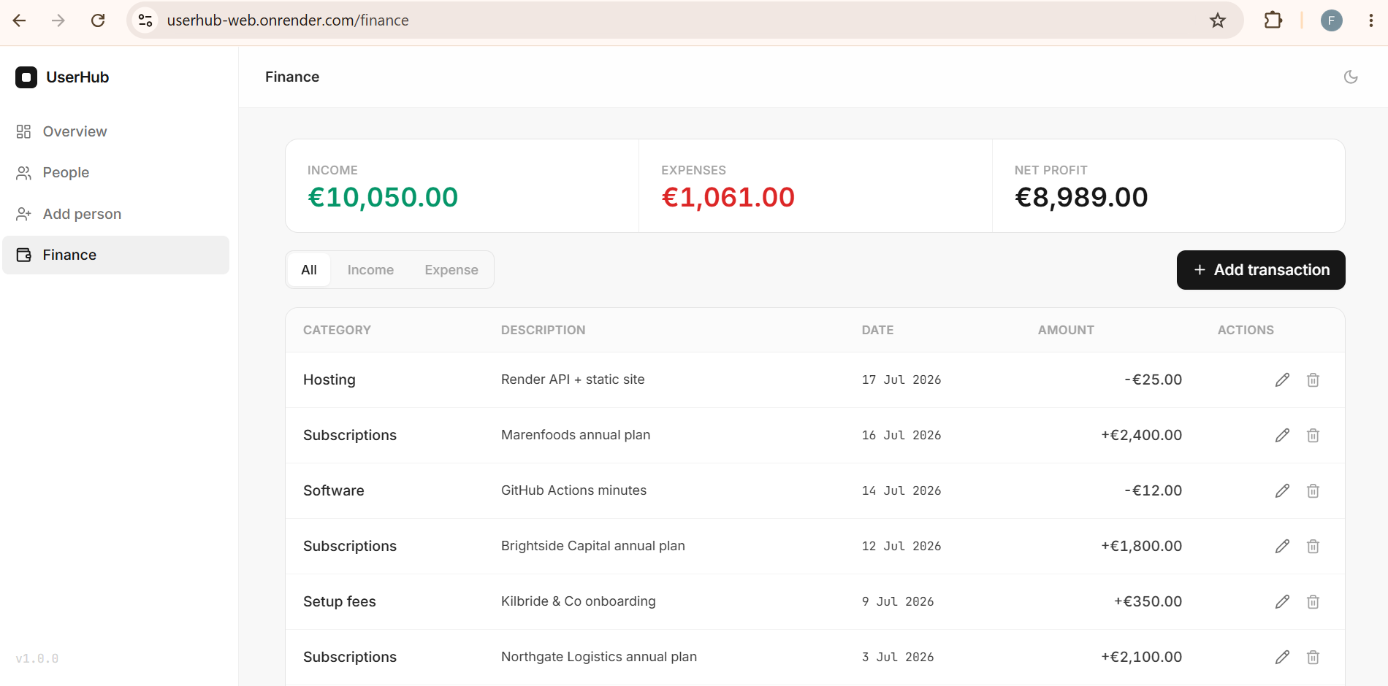
3.10 Data Persistence Layer
The data layer is implemented on PostgreSQL using the pg connection pool. Every query passes through a single db() helper that accepts positional placeholders and forwards them as parameterised values, so user input is never concatenated into SQL. The schema is created automatically at startup and consists of three tables: users (which includes a required company field alongside name, email, address, phone and a createdAt timestamp), transactions, and the auth_users table used for login accounts.
Test isolation is handled at the database level. When NODE_ENV is set to test, the application provisions a fresh, uniquely named database for the run and skips the seed data, so automated tests never touch real records and stay deterministic. In normal operation the database seeds itself with a set of realistic sample contacts and companies, so the dashboard metrics are meaningful on first deployment.
3.11 Health Checks and Logging
The service exposes dedicated health endpoints (/health, /ready and /live) that report whether the process is running and able to serve traffic. These are used by the hosting platform and by the post-deployment checks in the pipeline. Request and error logging middleware records each incoming request and any error passed to the Express error handler, which makes problems in the deployed environment easier to trace without exposing internal details to the client.

4. FRONT-END DESIGN
4.1 Framework, Structure and Routing
The front end I have built using React 18 a single page application using tailwind css. It communicates the the backend through a REST API, with all http requests that are managed from a single file(services/api.js). The project is oragnised into folders to keep the code easy to navigate. I have used Reusable UI components, such as avatars, modals, and loading skeletons and are stored In the components and the UI, while the user form is in the components or ui. The shared feature such as the theme and notifications are used for react context, data fetching is handled through custom hooks and a helper function that is kept in the utils folder.
Routing is handled with react router v6. The App Layout is providing a consistent layout with a sidebar and top navigation. While each page is put inside an outlet. Users will be able to navigate to the dashboard, view the contacts list, add a new contact list and add a contact and edit existing contacts, download a pdf profile and view a custom error 404 page if they enter the invalid route.
4.2 UI/UX and Componentisation
Componentisation and User Interface/Experience The application's UI design is simple, uncomplicated, and unified. To minimise code duplication and preserve a consistent user experience, reusable elements including buttons, modals, avatars, skeleton loaders, and toast alerts are used across the project. Every list has a consistent format, displaying the loading state, the actual data, an empty state when there are no records, or an error message if something goes wrong.. The dashboard displays essential metrics from the API, includes a debounced search field, and offers a breakdown of email domains for contacts. Both generating and modifying contacts are done using the same user interface, which has client-side validation that complies with server standards and shows API problems right on the form. Additionally, the program offers light and dark options, uses localStorage to store the user's preferred theme, and shows toast alerts following activities like adding, changing, or deleting contacts. The table arrangement changes and the sidebar transforms into a slide-out menu on small screens, guaranteeing that the application is still easy to use on mobile devices.
4.3 API Integration, State Management and Performance
To ensure code structure and avoid redundant setup throughout the project, all API requests are handled by a single Axios instance defined in services/api.js. I use a response interceptor to translate network and backend problems into understandable messages so that the remainder of the program may just utilise simple try/catch blocks. To control data retrieval and handle loading and error conditions, I created custom hooks called useUsers, useUser, and useStats. This keeps the page elements tidy and concentrated on showcasing the user interface.. React Context was adequate for sharing a few elements around the app, including the theme and toast alerts, so I didn't utilise Redux or Zustand because the most of the data is retrieved straight from the API. Skeleton loaders are shown while data loading to maintain page stability, and the search box has debouncing to stop queries from being sent on every keystroke. In addition to using Vite to produce an optimised production build, I have included semantic HTML and ARIA features to improve the application's accessibility.
4.4 Authentication and Protected Routes
The client includes a full authentication flow. Dedicated Login and Register pages collect credentials and call the auth endpoints, and an AuthContext holds the signed-in state and exposes login and logout actions to the rest of the app. The issued token is stored on the client and automatically attached to every outgoing request by the Axios request interceptor, while a response interceptor detects an expired or rejected token, clears it, and returns the user to the login screen.
Routes that require a signed-in user are wrapped in a ProtectedRoute component, so unauthenticated visitors are redirected to the login page rather than being shown protected content. This mirrors the server-side requireAuth guard, giving consistent protection on both the client and the server.
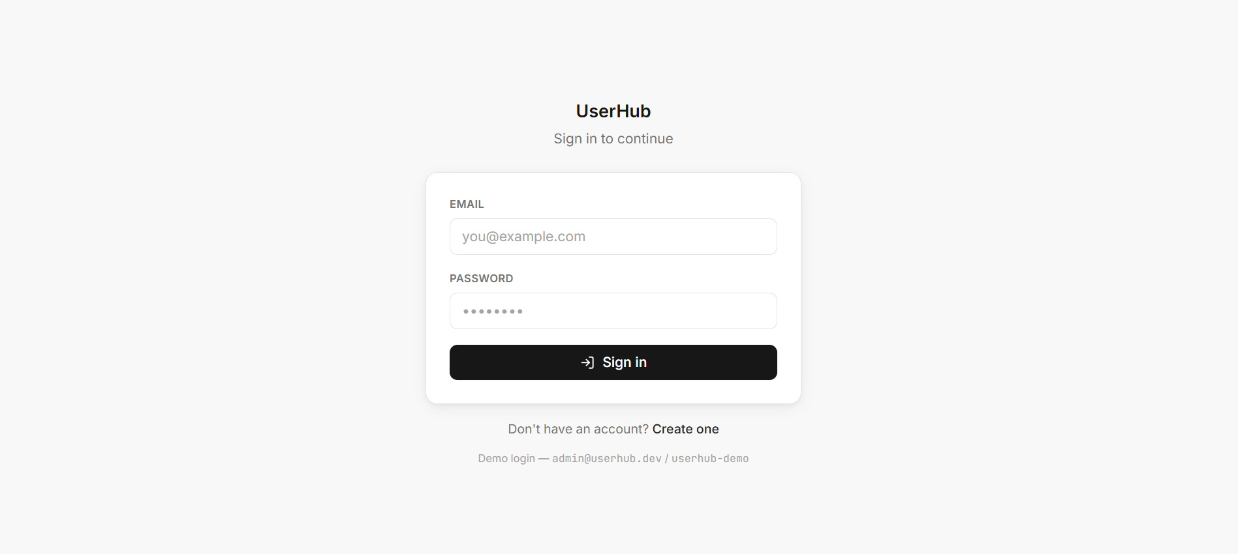
Figure 9: Sign-in screen — email/password login backed by the JWT auth flow, with a link to registration.
5. Library & Testing
5.1 PDF Profile Export
The PDFkit is used in server/lib/pdfExport.js to create the PDF export feature. It creates a one-page PDF with the user's information after receiving a user object. It can be independently tested and reused because it is independent of Express and the database.
Users can download a PDF profile straight from the application thanks to the library's connection to GET /api/user/:id/pdf. To make sure the PDF is generated and downloaded appropriately, it is tested using unit, functional, and system tests.
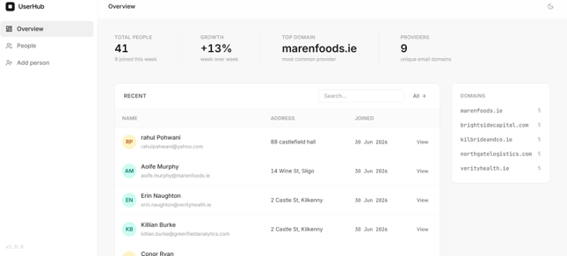
Figure 2: Dashboard — metrics, recent contacts, live search and domain breakdown.
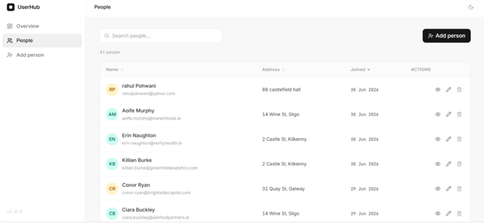
Figure 3:People list — sortable table, search, add action and per-row view/edit/delete.
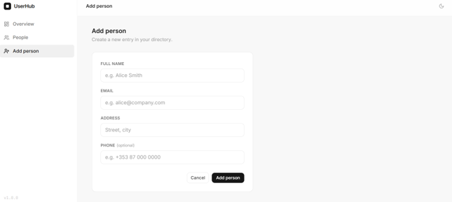
Figure 4: Add person form — inputs for name, email, address and optional phone.
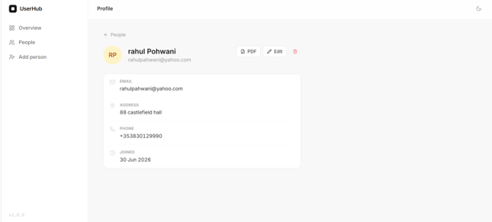
Figure 5: User profile — contact details with PDF export, Edit and Delete actions.
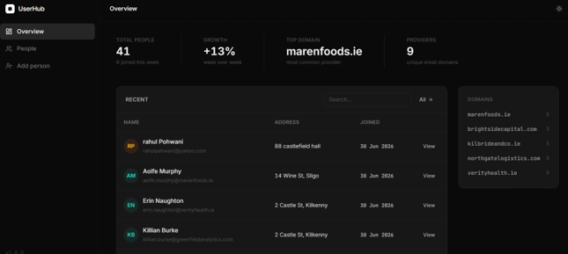
Figure 6: Dark mode — the same dashboard rendered with the light/dark toggle.

Figure 7: PDF export output — a generated one-page contact profile card, downloaded and opened in the browser.
5.2 Testing Strategy
The project includes tests of both the backend and frontend. The tests are grouped into two different levels and they are including tests such as unit , integration , functional and smoke tests and each of the groups can be run using npm run tests and it is also included in the CI pipeline , makjng it easy to identify where any failures occur
5.3 Unit and Integration Testing
Unit tests check that individual functions and components work as expected. For example, validate.test.js verifies that invalid names, emails, and addresses are rejected, while pdfExport.test.js checks that a valid PDF is generated, even when optional fields are missing. On the frontend, UserForm.test.jsx confirms that validation works correctly and API errors are displayed to the user.
Integration tests check how different parts of the application work together. On the backend, db.test.js uses the real PostgreSQL database to confirm that constraints such as unique email addresses are enforced. On the frontend, integration tests verify that the Axios API layer returns errors in the format expected by the components.
5.4 Functional and Smoke Testing
Functional tests cover the application's main features from end to end. The backend tests create, read, update, and delete contacts, while also checking duplicate emails, validation errors, and the PDF download endpoint. The frontend tests verify that contacts are displayed correctly, and that search, sorting, filtering, editing, and deleting all work as expected. Smoke tests simply confirm that the application starts correctly and that the main pages and API endpoints are available without errors.

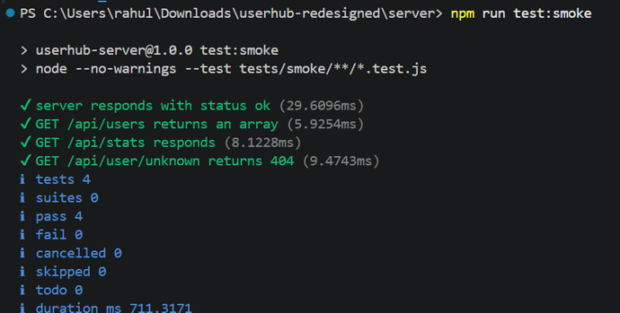
Figure 10: Backend smoke tests — endpoint availability and response-shape checks (4 tests, 0 failures).
5.5 System testing and combined suite
System tests are an excellent way to verify the deployed system. The reason for this is that the test suite initiates a Node server holds upand waits for it to begin operating on a port. After that, it performs every action a user would take over HTTP. It will generate, read, list, update, download, and remove a PDF. There are no imports or mocks used in the test suite. If a system test is unsuccessful, it indicates that the system is actually not working . things like file input and output, port binding, and environment variables. that the other tests are unable to identify.When you run all the tests together using npm test you get the results. For example Figure 12 shows that 24 tests were run and they all passed.
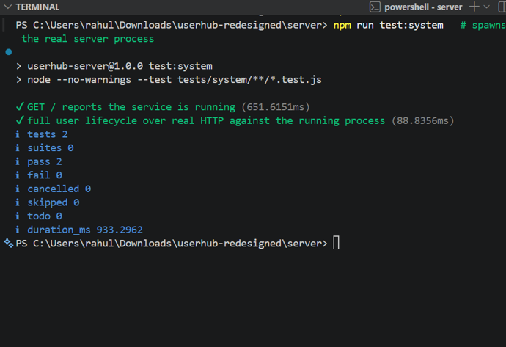
Figure 11: System tests — real server process and full lifecycle over live HTTP (2 tests, 0 failures).
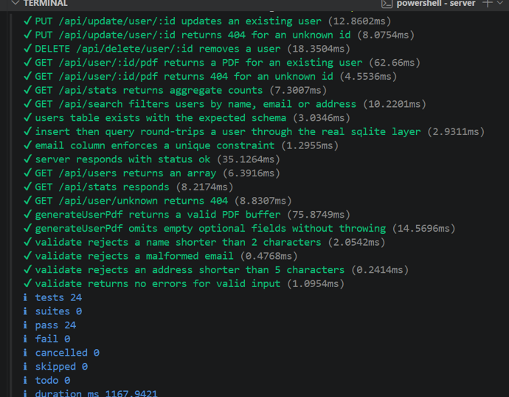
Figure 12: Combined backend suite — unit + integration + functional + smoke: 24/24 passing.
5.6 Frontend test suite and test isolation
Frontend uses Vitest and React Testing Library, which tests components from the user's perspective, not implementation details. Unit tests cover helpers and UserForm. Integration tests cover the API service and error handling. Functional tests drive the full UsersPage feature. Smoke tests render the routed app.
Test isolation: backend forces NODE_ENV=test so a fresh, isolated database is used and seed data is skipped. Frontend mocks only the network boundary so real hooks and components always run.
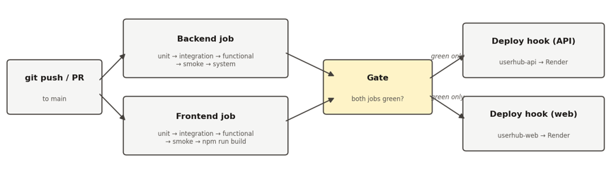
Figure 14: Frontend unit, integration, functional tests - 66/66 passing
Figure 15: Frontend API integration tests - 25/25 passing
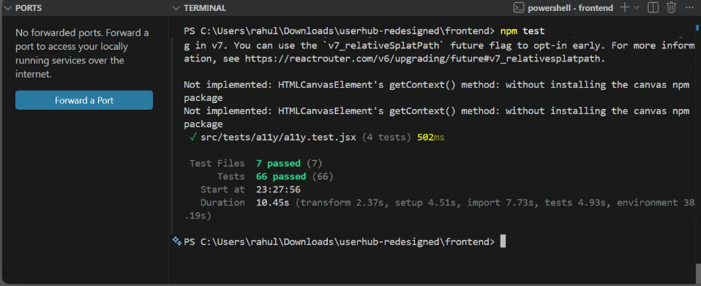
Figure 16: Frontend smoke tests - 3/3 passing
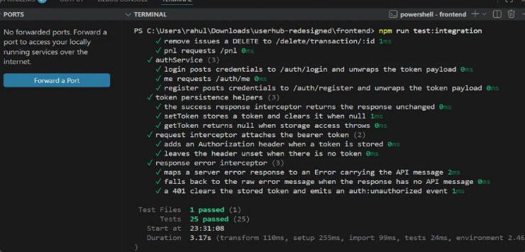
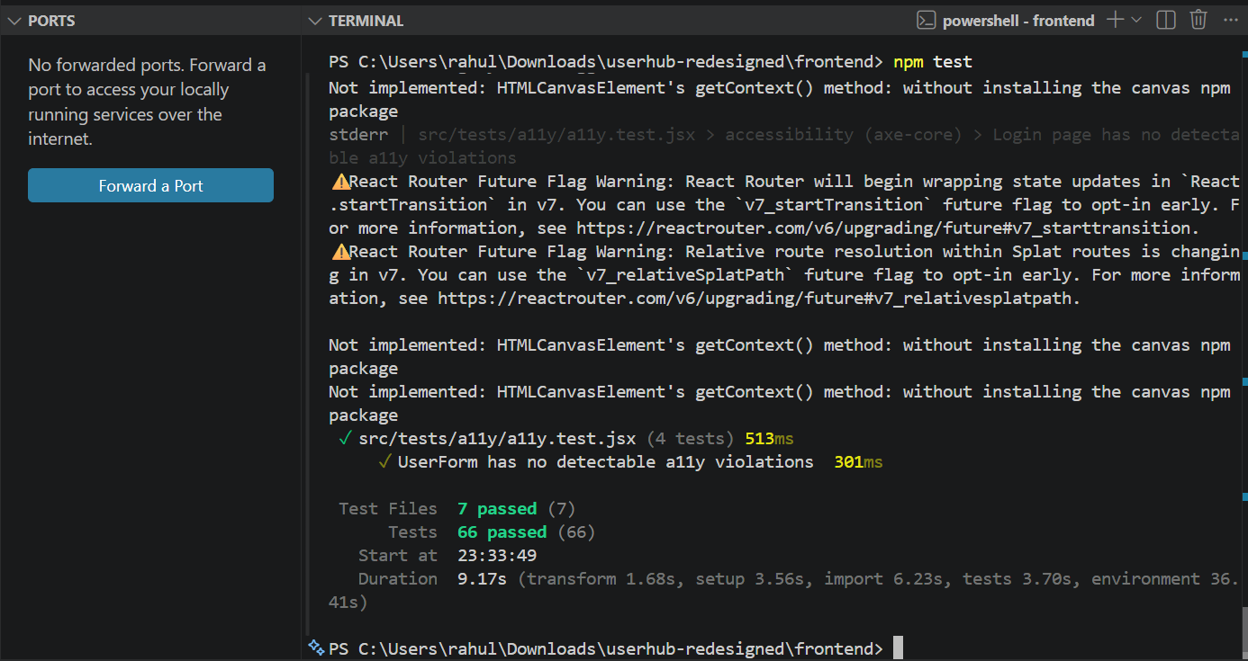
Figure 17: Frontend accessibility tests - 66/66 passing with no violations
5.7 Transaction Testing
The transactions API is thoroughly tested by transactions.test.js. It creates, reads, updates, and deletes transactions, covering the entire CRUD process. Incorrect transaction types, short category names, negative sums, and erroneous dates are just a few examples of the invalid inputs that the tests verify for. Furthermore, a set of sample transactions, including edge cases where no transactions occur for a specific category or month, are evaluated to make that the /api/pnl endpoint provides the right totals.
6. Continuous Integration / Continuous Deployment (CI/CD)
6.1 Continuous Integration with GitHub Actions
Every time a pull request is made for the main branch or a change is submitted, I utilise GitHub Actions to automatically test the project. The frontend tests (unit, integration, functional, and smoke) are executed after the backend tests (unit, integration, functional, smoke, and system). In order to ensure that the production version of the application builds correctly, it then executes npm run build.
GitHub Actions makes it obvious which step was the source of any stage failures. To ensure that only fully tested code may be deployed, the deployment job only begins when both the frontend and backend test jobs have been completed.
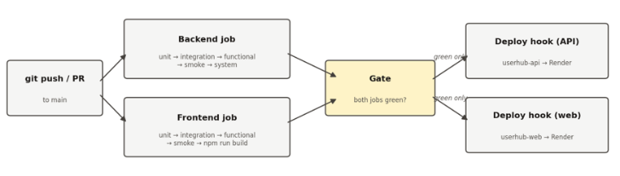
Figure 13: The gated CI/CD pipeline — both jobs must pass every test tier before deployment; any red blocks.
6.2 Continuous Delivery to Render
The program is hosted on Render and automatically deployed via GitHub Actions. GitHub Actions initiates requests to Render deployment hooks that are safely stored in GitHub Secrets after the CI workflow is successful, guaranteeing that no API keys are disclosed. The frontend is hosted as a static Vite site with the API URL set at build time, while the backend functions as a Node.js web service. Render.yaml specifies the deployment setup, making it simple to replicate the configuration or independently reinstall either service.So to deploy my project I had to go onto render and create two static sites one for the backend and one for the frontend after that I had to create environment variable such as entering vite id and jwt id and backend external id and to run the backend I had to enter the vite id in so my project could run when data was entered
6.3
Recognized Constraints
The app uses a PostgreSQL database hosted on Render. This is suitable for the project, and a larger deployment would add automated backups and a higher service tier for extra resilience. The application uses JWT-based authentication rather than a full role-based permission system, which would be a natural next step for a larger deployment. Ultimately, the backend operates as a single instance, which is adequate for this project but would require scaling for a more extensive application.
6.4 Additional Pipeline Stages and Quality Gates
Beyond running the tests, the pipeline enforces several quality gates. ESLint runs as a blocking step on both the backend and the frontend, and a Prettier formatting check runs for information. Code coverage is measured on both projects and the build fails if coverage falls below the eighty-percent threshold. A dependency vulnerability audit runs on each project, and the frontend job additionally runs the accessibility test suite and produces an optimised production build.
Two further GitHub Actions workflows add security scanning: CodeQL performs static analysis of the codebase for common vulnerability patterns, and a dependency-review workflow inspects dependency changes on pull requests. After a successful deployment, a post-deployment smoke test waits for the live API to report healthy and then exercises the deployed endpoints, giving automated evidence that the release is working. The PostgreSQL database used by the backend test job is provided as a service container inside the workflow.
7. Safety
Security was taken into consideration throughout the build, and the API is protected by token-based authentication. To avoid SQL injection, parameterised statements are used in all SQL queries, and both server and client validation is carried out. A database uniqueness constraint protects email addresses; UUIDs are used in place of sequential IDs; CORS only permits requests from the frontend; and GitHub Secrets is used to store sensitive variables like deployment hooks. Additionally, error answers are kept generic to avoid revealing extraneous details.8. Design Decisions and Compromises.
8. To facilitate testing and maintenance, the project employs a layered architecture that keeps the PDF library apart from the HTTP layer. The infrastructure is defined by code, and the frontend and backend are implemented as distinct services. I chose PostgreSQL as the relational database because it runs reliably on the cloud platform and works cleanly with the parameterised queries used throughout the backend. This gives the project a clear path to scale as it grows. In order to give immediate feedback while maintaining backend validation, I additionally replicated validation rules on the client and server. Semantic HTML and aria-* attributes were used across the application to increase accessibility.
9. Rationale for the Technology Stack
Because Node.js and Express are lightweight and ideal for creating REST APIs, I utilise them. React and Vite produce an efficient production build and offer a quick development experience. PostgreSQL was chosen for this project because it is a reliable relational database that is well supported on the cloud platform and integrates cleanly with the Node.js backend. Since PDFkit satisfied all project criteria, it was used to create PDF exports. I looked into alternatives like Flask and Next.js, but they would have contradicted the objective of keeping the frontend and backend distinct or added needless complexity.
10. Conclusion
With a real database, a responsive React UI, and a REST API, UserHub is a full-stack application. Validation, PDF output, multi-level automated testing, and a CI/CD pipeline that pushes the frontend and backend to the cloud are all included. The project is easy to maintain and expand, and it exhibits solid software engineering techniques.
Conclusion
By creating a fully functional SaaS application with React, Express, PostgreSQL, and a RESTful API, this project effectively met the goals of the Cloud Application Development module. Complete CRUD capability, a reusable PDF generation library, multi-level automated testing, and a CI/CD pipeline for dependable deployment are all offered by UserHub. The project improved my knowledge of software testing, full-stack cloud application development, and contemporary deployment techniques while showcasing my capacity to create a scalable and maintainable web application.
References

Axios (2026) Axios HTTP Client Documentation. Available at: https://axios-http.com/docs/intro
Express.js (2026) Express 4x API Reference. Available at: https://expressjs.com/en/4x/api.html
GitHub (2026) GitHub Actions Documentation. Available at: https://docs.github.com/en/actions
node-postgres (2026) node-postgres (pg) Documentation. Available at: https://node-postgres.com
PDFKit (2026) PDFKit JavaScript PDF Generation Library. Available at: https://pdfkit.orgReact (2026) React Documentation. Available at: https://react.dev
Render (2026) Render Documentation. Available at: https://render.com/docs
Tailwind Labs (2026) Tailwind CSS Documentation. Available at: https://tailwindcss.com/docsVite (2026) Vite Guide. Available at: https://vitejs.dev/guide

